Problem 9
A disaster relief team needs to inspect all buildings in a city after an earthquake. The city is mapped as a network where buildings are connected by roads. One team starts at a building and goes as deep into each road as possible before backtracking, while a second team spreads out level by level — first checking all buildings directly connected to the start, then all buildings two roads away, and so on. Given the city map as a graph and a starting building, implement both exploration strategies and print the order in which buildings are visited by each team. Describe how the order of buildings visited differs between the two strategies on the same graph. What data structure does each strategy rely on to decide which building to visit next, and how does that structure cause the difference in order?

Code:

Output:
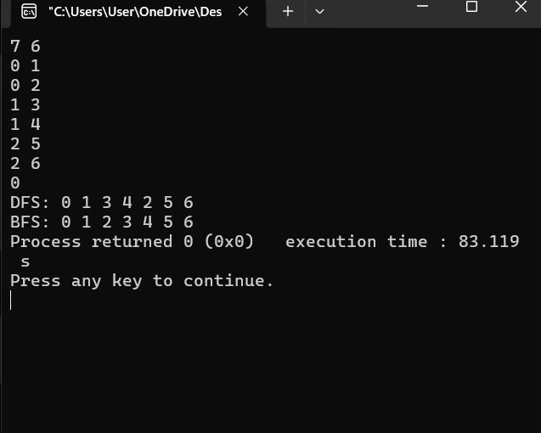

Problem Faced
The main problem was understanding the difference between DFS and BFS and how to keep track of the nodes that have already been visited. It was also difficult to understand how DFS uses recursion while BFS uses a queue to visit the nodes.
Solution
The problem was solved by using a visited array to prevent visiting the same node repeatedly. DFS recursively visits an unvisited neighboring node and goes as deep as possible before coming back. BFS uses a queue and visits the neighboring nodes level by level. The graph is stored using an adjacency list, which makes it easy to find the connected nodes.

